Hands on 1 : Create a Spring Web Project using Maven

SpringLearnApplication.java

package com.cognizant.spring_learn;
import org.slf4j.Logger;
import org.slf4j.LoggerFactory;
import org.springframework.boot.SpringApplication;
import org.springframework.boot.autoconfigure.SpringBootApplication;
@SpringBootApplication
public class SpringLearnApplication {
private static final Logger LOGGER =
LoggerFactory.getLogger(SpringLearnApplication.class);
public static void main(String[] args) {
LOGGER.info("START");
SpringApplication.run(SpringLearnApplication.class, args);
LOGGER.info("END");
}
}

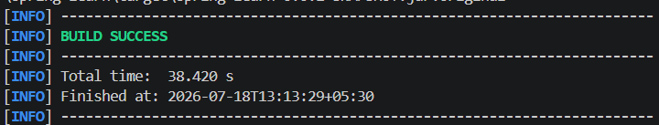

Hands on 4 : Spring Core - Load Country from Spring Configuration XML

Country.java

package com.cognizant.spring_learn;

import org.slf4j.Logger;
import org.slf4j.LoggerFactory;

public class Country {

private static final Logger LOGGER =
LoggerFactory.getLogger(Country.class);

private String code;
private String name;

public Country() {
LOGGER.debug("Inside Country Constructor.");
}

public String getCode() {
LOGGER.debug("Inside getCode()");
return code;
}

public void setCode(String code) {
LOGGER.debug("Inside setCode()");
this.code = code;
}

public String getName() {
LOGGER.debug("Inside getName()");
return name;
}

public void setName(String name) {
LOGGER.debug("Inside setName()");
this.name = name;
}

@Override
public String toString() {
return "Country [code=" + code + ", name=" + name + "]";
}
}

SpringLearnApplication.java

package com.cognizant.spring_learn;

import org.slf4j.Logger;
import org.slf4j.LoggerFactory;
import org.springframework.boot.SpringApplication;
import org.springframework.boot.autoconfigure.SpringBootApplication;
import org.springframework.context.ApplicationContext;
import org.springframework.context.support.ClassPathXmlApplicationContext;

@SpringBootApplication
public class SpringLearnApplication {

private static final Logger LOGGER =
LoggerFactory.getLogger(SpringLearnApplication.class);

public static void main(String[] args) {

LOGGER.info("START");

SpringApplication.run(SpringLearnApplication.class, args);

displayCountry();

LOGGER.info("END");
}

public static void displayCountry() {

ApplicationContext context =
new ClassPathXmlApplicationContext("country.xml");

Country country =
context.getBean("country", Country.class);

LOGGER.debug("Country : {}", country.toString());

}
}

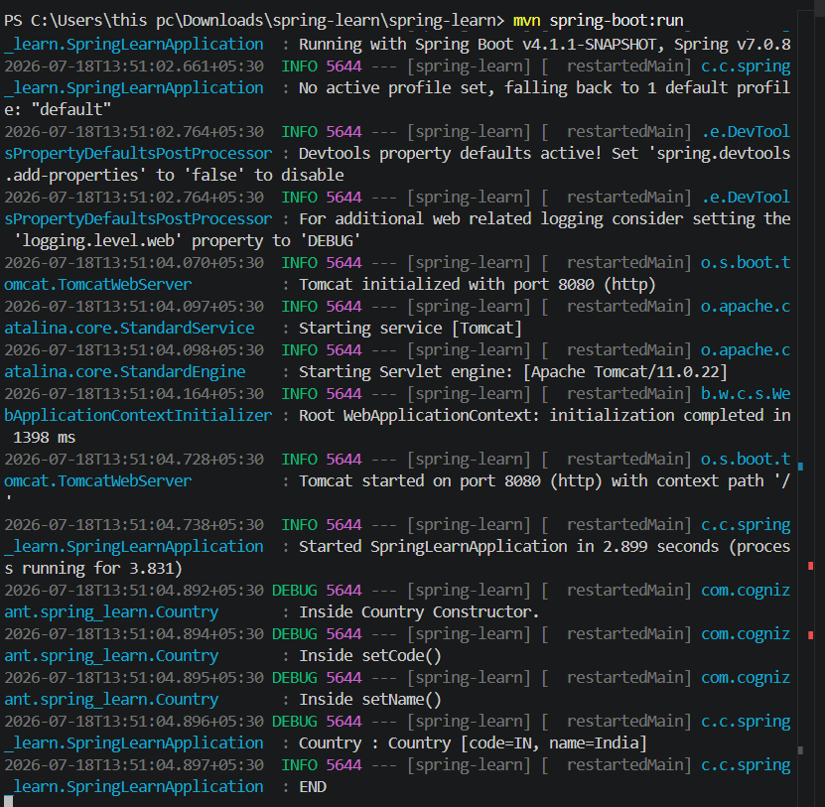

Hello World RESTfull Web Service

HelloController.java

package com.cognizant.spring_learn.controller;

import org.slf4j.Logger;
import org.slf4j.LoggerFactory;
import org.springframework.web.bind.annotation.GetMapping;
import org.springframework.web.bind.annotation.RestController;

@RestController
public class HelloController {

private static final Logger LOGGER =
LoggerFactory.getLogger(HelloController.class);

@GetMapping("/hello")
public String sayHello() {

System.out.println("Inside sayHello()");

LOGGER.info("START");

String message = "Hello World!!";

LOGGER.info("END");

return message;
}
}

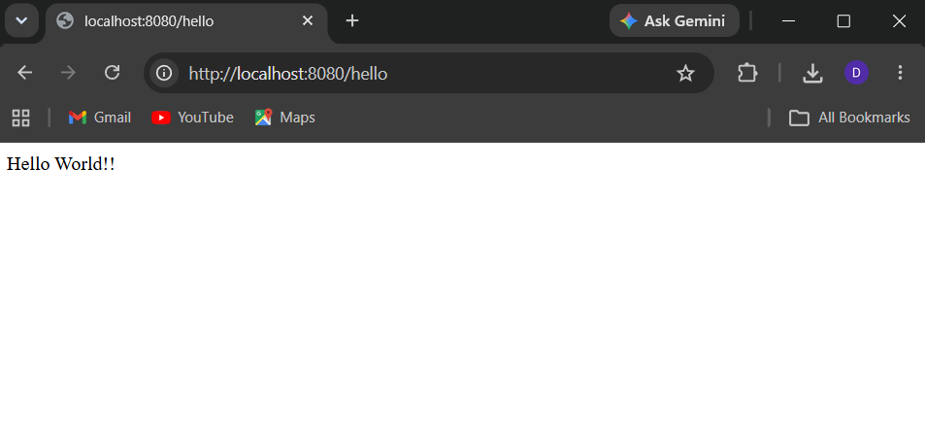
REST - Country Web Service

CountryController.java

package com.cognizant.spring_learn.controller;

import org.slf4j.Logger;
import org.slf4j.LoggerFactory;
import org.springframework.context.ApplicationContext;
import org.springframework.context.support.ClassPathXmlApplicationContext;
import org.springframework.web.bind.annotation.RequestMapping;
import org.springframework.web.bind.annotation.RestController;

import com.cognizant.spring_learn.Country;

@RestController
public class CountryController {

private static final Logger LOGGER =
LoggerFactory.getLogger(CountryController.class);

@RequestMapping("/country")
public Country getCountryIndia() {

LOGGER.info("START");

ApplicationContext context =
new ClassPathXmlApplicationContext("country.xml");

Country country = context.getBean("country", Country.class);

LOGGER.info("END");

return country;
}
}

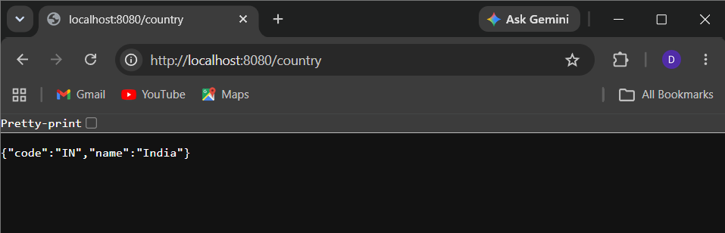

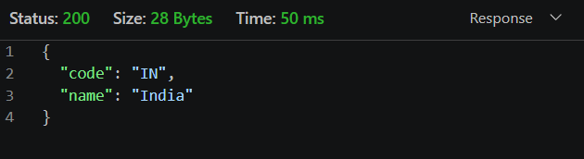

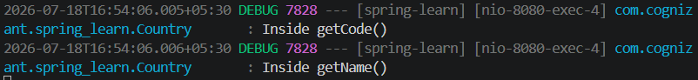

REST - Get Country Based On Country Code

CountryService.java

package com.cognizant.spring_learn.Service;

import java.util.List;

import org.springframework.context.ApplicationContext;
import org.springframework.context.support.ClassPathXmlApplicationContext;
import org.springframework.stereotype.Service;

import com.cognizant.spring_learn.Country;

@Service
public class CountryService {

@SuppressWarnings("unchecked")
public Country getCountry(String code) {

ApplicationContext context =
new ClassPathXmlApplicationContext("country.xml");

List<Country> countryList =
(List<Country>) context.getBean("countryList");

for (Country country : countryList) {

if (country.getCode().equalsIgnoreCase(code)) {
return country;
}
}

return null;
}
}

